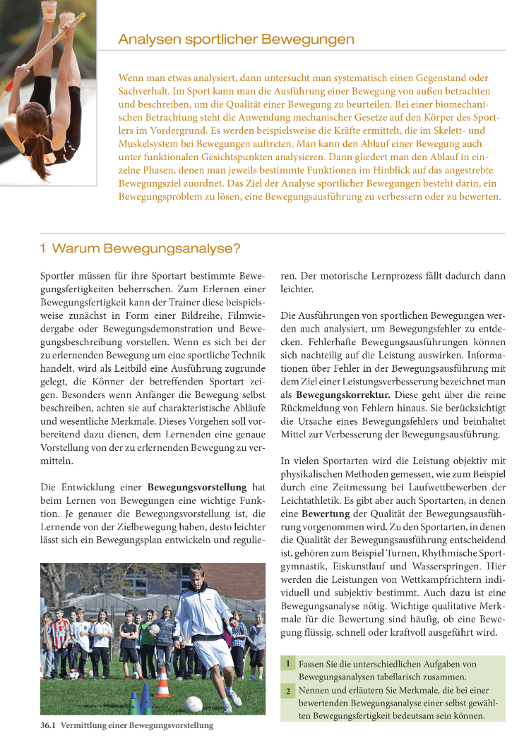

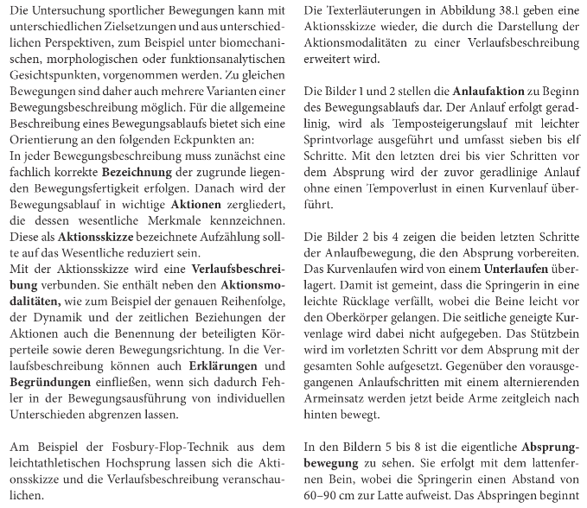
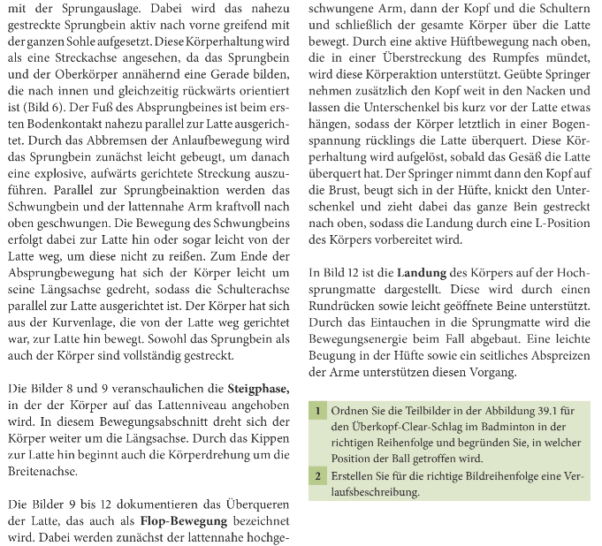
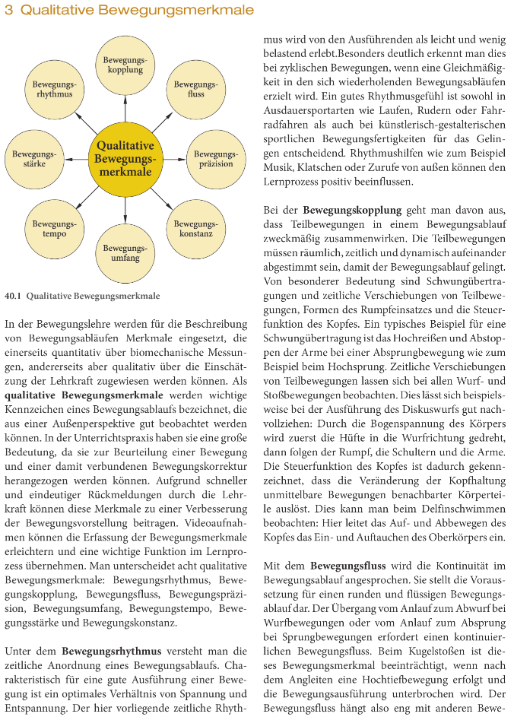

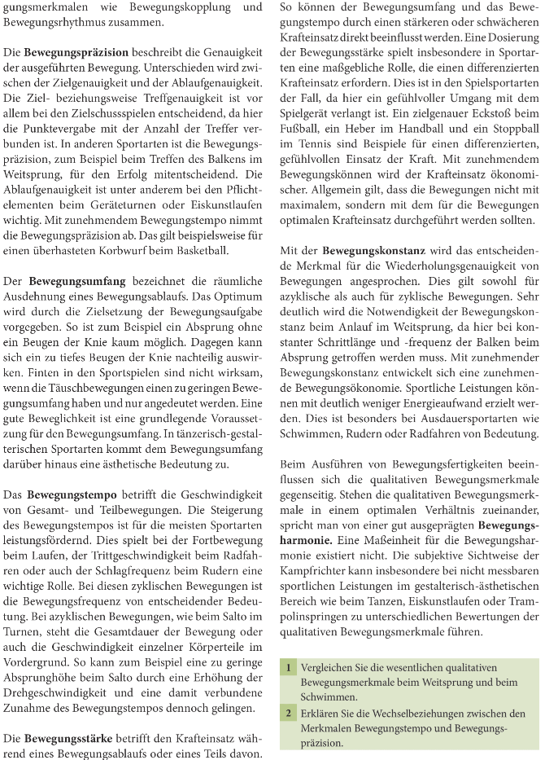

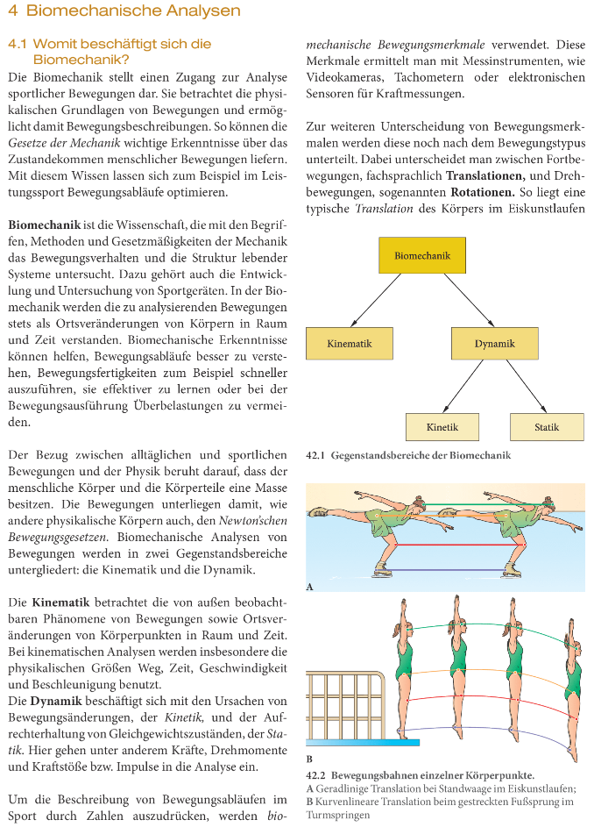

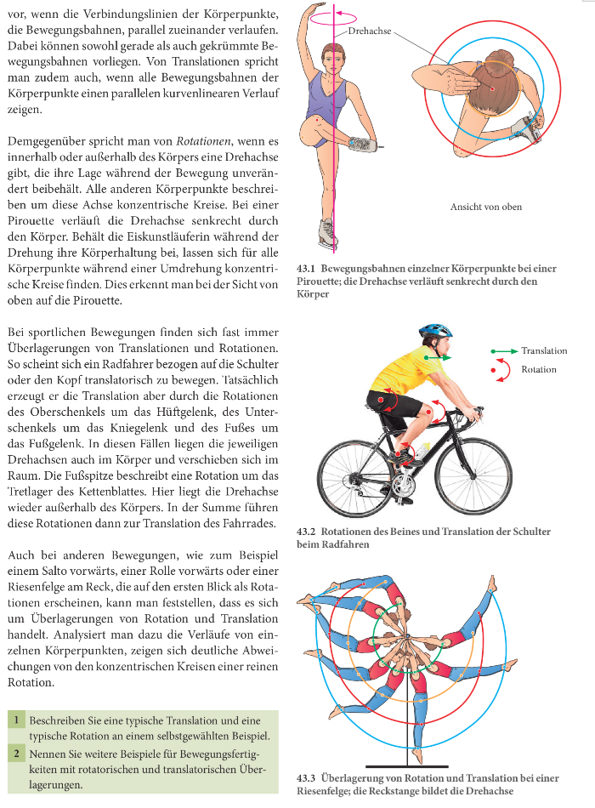

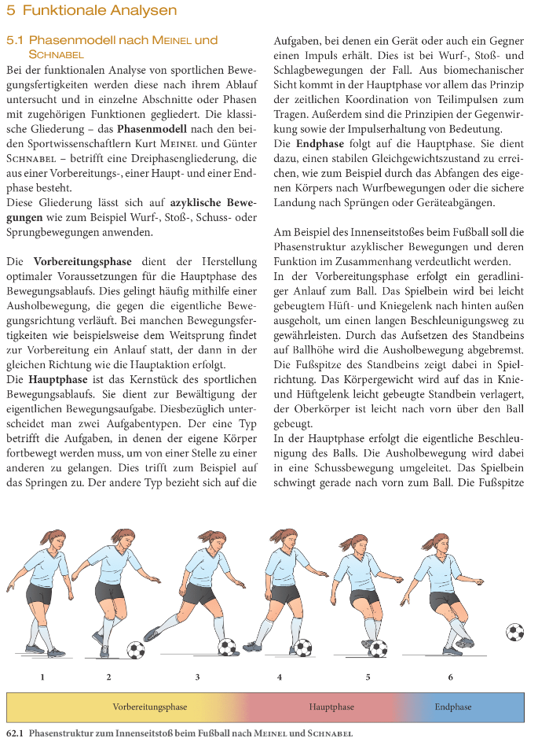

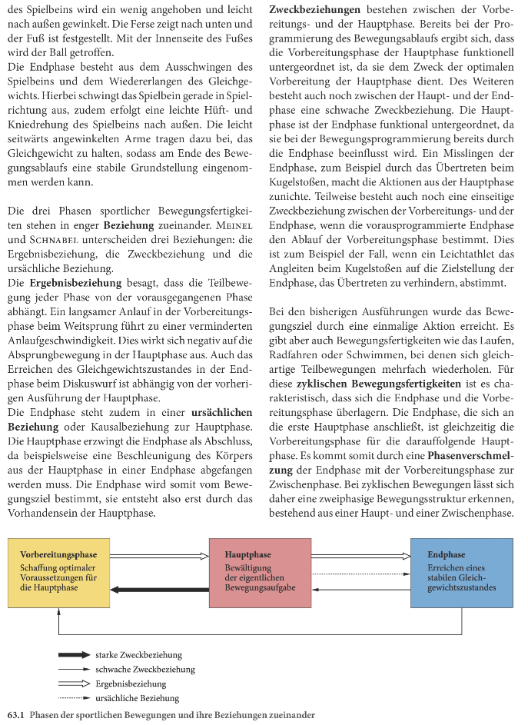

Arbeitsblatt Bewegungsanalyse (Sport / FRÖ) 04.11.2025

Spieleranalyse
Vorname, Name: _______________________________________________

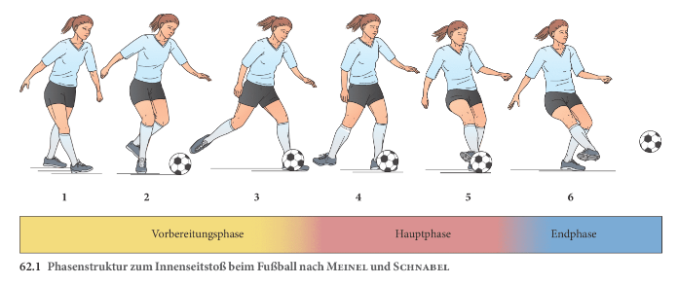

Positiv/Negativ… Übungsmöglichkeiten… Ziele…
_______________________________________________________________________________________________________________________________________________________________________________________________________________________________________________________________________________________________________________________________________________________________________________________________________________________________________________________________________________________________________________________________________________________________________________________________________________________________________________________________________________________________________________________________________________________________________________________________________________________________________________________________________________________________________________________________________________________________________________________________________________________________________________________________________________________________________________________________________________________________________________________________________________________________________________________________________________________________________________________________________________________________________________________________________________________________________________________________________________________________________________________________________________________________________________________________________________________________________________________________________________________________________________________________________________________________________________________________________________________________________________________________________________________________________________________________________________________________________________________________________________________________________________________________________________________________________________________________

